**Problem**: *Rate A Read With GoodReads*

They say “ *If you want to be a writer, you must do two things above all others: read a lot and write a lot*”. Well, that’s maybe the primary element, but in this age of Science, some data and some analysis may work as a wonder!

In this project, I want to work on predicting a Book's popularity or acceptability based on some features of other books on the same subject.

**Data**:

Goodreads:<https://www.goodreads.com/api>

I want to use the API to fetch all the books from Goodreads for a search keyword. I plan to get book_id, ISBN, author(s), total_pages in the book, average_rating, rating_count, text_reviews_count, publisher, popular Shelves for the book and description. Also, I could use the API to get the author details.

Below is a screenshot of a sample data file for books on Machine Learning that is grabbed from Goodreads using the api.

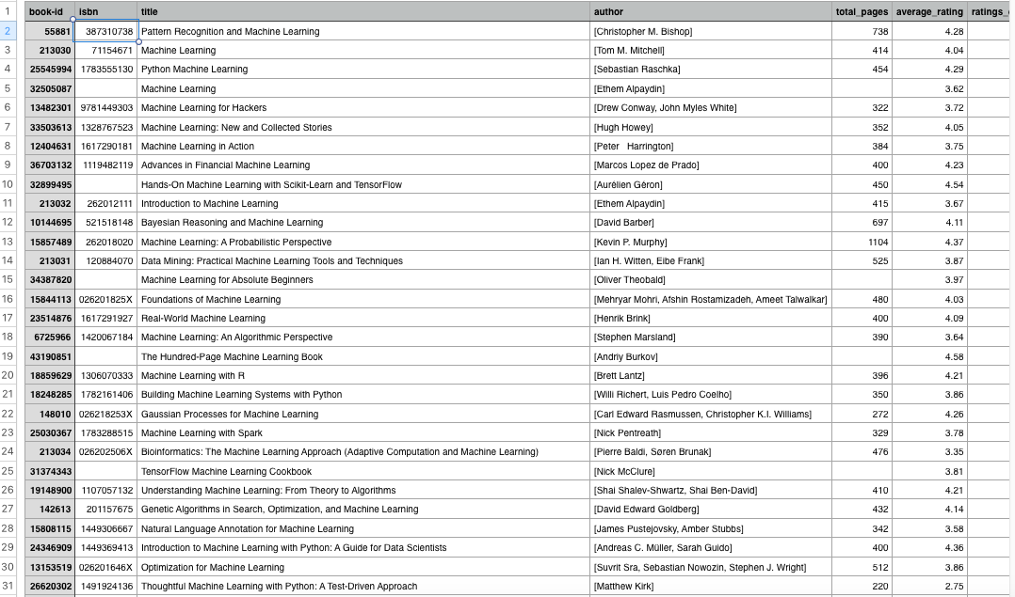

**Client**:

I am not aware if a tool like that already exist. But I hope any prospective writer could use the tool to get an idea of the future of the book before it is launched. A writer puts a lot of efforts into writing a book. So, it can be a good idea to check the market on existing books. What makes a book popular or what are the determinants in a book which earns a good rating? So, to all the authors out there "Pour your heart and create a Classic, but let's do it scientifically"!

**Approach**:

I will create a CSV file with all the information.

I will use some data wrangling to clean up the data and create some new features.

I will perform Exploratory Data Analysis to identify any meaningful trends.

Finally, I will build a predictive model based on those features to Predict a rating for a book.

**Deliverables**:

My deliverables will include code on Github along with a Jupyter Notebook and if possible a Cool application to use for any writers out there.